## 

## Merchant Demo date: Oct 8, 2024 Scoping start date: Oct 8, 2024

MSA Signature Date: Nov 25, 2024  
Onboarding Kick Off Date: Dec 2, 2024

[If Exists] Opt Out Date: Oct  
Go Live Date: Jan 1, 2025

GTM POC: Nick  
Implementation POC: Dani

ERP: QBO

Tax Integration: Avalara

### 

### Key people at Merchant

### Head of Business Operations: Julie Castelbaum - https://www.linkedin.com/in/julie-castelbaum/

### CFO:

### Customer service rep who is really involved:

* Account Receivable POC: Julie (head of biz ops)
* Billing POC

### Etc.

### 

| Notes Sections [Ops International Team to Ignore] *(AE/ Implementation to fill)*   * Info on how merchant bills   + Subscription fees   + Per User fees * Is there any important merchant relationship information? Another Primary PortCo 1) What is the merchant temperament? * Smart. Wishy Washy a little bit when it comes to aligning on action plans for success 2) Is there a key POC: (i.e.: who is the buyer/decision maker?)   + Julie Castelbaum- responds with simple emails   + What are the Tabs features that the key POC cares about?   + Invoicing, **Rev Rec**, ARR Reporting, and Renewals management * **ARR Reporting is going to be key** * 80 customers in October   + Simple contract   + Only 1 contract per customer (?) * Pain points   + Automation |
| --- |

### 

Company summary  
*(AE to fill)*

Cargado is a cross-border logistics startup built to connect everyone involved in cross-border Mexico freight.

Goals (North star)  
*(AE/ Implementation to fill)*

What is the merchant's goal? What pain are we solving? Why are they buying Tabs?

Experiencing extreme growth and do not have a finance person in house. All invoicing falling under Julie and now incorporating per user pricing. Have been on Stripe and do not have a way to manage the new model

*Automation, ease of use*   
Is there an opt out clause? If so, what is the merchant looking for so they do not exercise it?

No

### Billing model *(AE/ Implementation to fill)*

* Are there unique things about the customer creation process for this merchant?
  + Subscription and per user fees
  + Per seat with overages
* Information on how merchant bills
  + Monthly, some annual
  + Some quarterly
  + Do have a usage component
* How contract is broken up
  + Simple contracts
* One off things to know about the merchant

### 

### 

### Contract Processing Steps *(Implementation/Success to fill)*

* **General**
  + Almost all contracts will have 3 BTs
    - “Subscription Fee”
    - “Additional Postings”
    - “Additional Quotes”
  + Most contracts will be quarterly billing

#### **Item Name:**

* + “Subscription Fee”
  + “Additional Postings”
  + “Additional Quotes”
  + If none of the above, use best judgement

#### **Quantity:** 1 for the flat subscription fees

#### **Total Price:**

#### Use the monthly fee multiplied by the frequency (quarterly = 3, annually = 12)

* + For overage fees, use the per-unit fee (e.g., $24.99 per additional quote or post)

#### **Service Start Date: “**Billing Start and Frequency”:

#### **Billing Start Date:** same as service start date

#### **Months of Service:** "Initial Subscription Term" stated in the Order Form

#### **Frequency:**

* + Most likely quarterly unless stated otherwise
  + Usage BT should match this billing frequency

#### **Net Terms:** 30

* **Tiered Unit BTs (Additional Postings or Quotes)**
  + 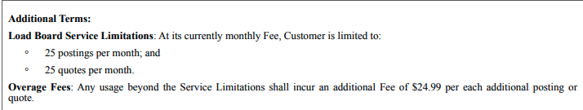
  + [Example](https://garage.tabsplatform.com/prod/contracts/a75d0ef1-1a16-4fbc-bd36-e06312fb6d16/terms/revenue)
    - Multiply quantity by 3 if quarterly billing
    - Keep price the same
* 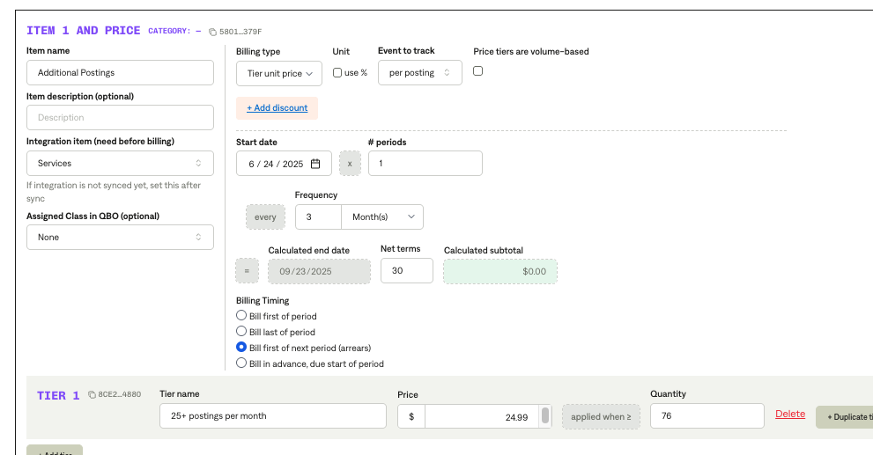
  + 1 tier
    - Title can be the monthly amount
    - Price can stay is listed in the contract
    - Multiply the quote and posting limit by 3 and add 1 if quarterly billing
* **Amendments:** process under the NEW contract

### Events Processing (if necessary) *(Implementation/Success to fill)*

* Any important information on events billing

Integration Items Processing (if necessary)  
*(Implementation/Success to fill)*

* What are the instructions for assigning integration items?
* Example: All Statsig integrations items should be labeled as “Sales”
* Example: All “Pinata” integration items should be labeled as “Software Subscription Bundle” unless otherwise noted by Merchant

Post Processing Communications (if necessary)  
*(Implementation/Success to fill)*

* Does the Ops Team need to notify anyone on the team re: completion of processing batches in Implementation or Active phase?
* Who needs to be notified and when?
  + Example:
    - Who: Customer Success [Azmat Aziz] needs to be notified
    - Where: Messari internal merchant channel
    - When: contracts are processed [Merchant Phase: Active]

### Customer Information *(Implementation/Success to fill)*

* Any important information on specifics customers of this merchant
  + Special memo’s certain invoices require
  + Invoice changes due to merchant/customer relationship

### Feature Requests *(AE/Implementation/Success to fill)*

* FR 1
  + What is it
  + Why it's important
  + Urgency

### Rewatch Calls *(AE/Implementation/Success to fill)*

* Disco - 10/6/24
  + <https://tabs.rewatch.com/video/kaysh845s5p24k3e-cargado-tabs-intro-october-8-2024>
* Custom Demo - 10/17/24
  + <https://tabs.rewatch.com/video/y3mbavl6x9gntkne-cargado-tabs-custom-demo-october-17-2024>
* Commercials Sync - 10/28/24
  + <https://tabs.rewatch.com/video/zdkmwazm4w52jjdh-cargado-tabs-feedback-sync-october-28-2024>